**REPORT**

**About the data**  
This data was collected through google forms and made as a fun project during COVID-19 lockdown. Information about investment interests, people behavior and management

**Attribute**

* gender: GENDER,
* age: AGE,
* Investment_Avenues: Do you invest in Investment Avenues?,
* Mutual Funds: What do you think are the best options for investing your money? (Rank in order of preference)
* Equity Market: What do you think are the best options for investing your money? (Rank in order of preference)
* Debentures: What do you think are the best options for investing your money? (Rank in order of preference)
* Government Bonds: What do you think are the best options for investing your money? (Rank in order of preference)
* Fixed Deposits: What do you think are the best options for investing your money? (Rank in order of preference)
* Public Provident Fund: What do you think are the best options for investing your money? (Rank in order of preference)
* Gold: What do you think are the best options for investing your money? (Rank in order of preference)
* Stock_Market: Do you invest in the Stock Market?
* Factor: What are the factors considered by you while investing in any instrument?
* Objective: What is your investment objective?
* Purpose: What is your purpose behind the investment?
* Duration: How long do you prefer to keep your money in any investment instrument?
* Invest_Monitor: How often do you monitor your investment?
* Expect: How much return do you expect from any investment instrument?
* Avenue: Which investment avenue do you mostly invest in?
* What are your savings objectives?: What are your savings objectives?
* Reason_Equity: Reasons for investing in Equity Market
* Reason_Mutual: Reasons for investing in Mutual Funds
* Reason_Bonds: Reasons for investing in Government Bonds
* Reason_FD: Reasons for investing in Fixed Deposits
* Source: Your sources of information for investments is

There are 24 attribute in the dataset and 40 rows.

**Count of people who related to stock market and investment by gender**

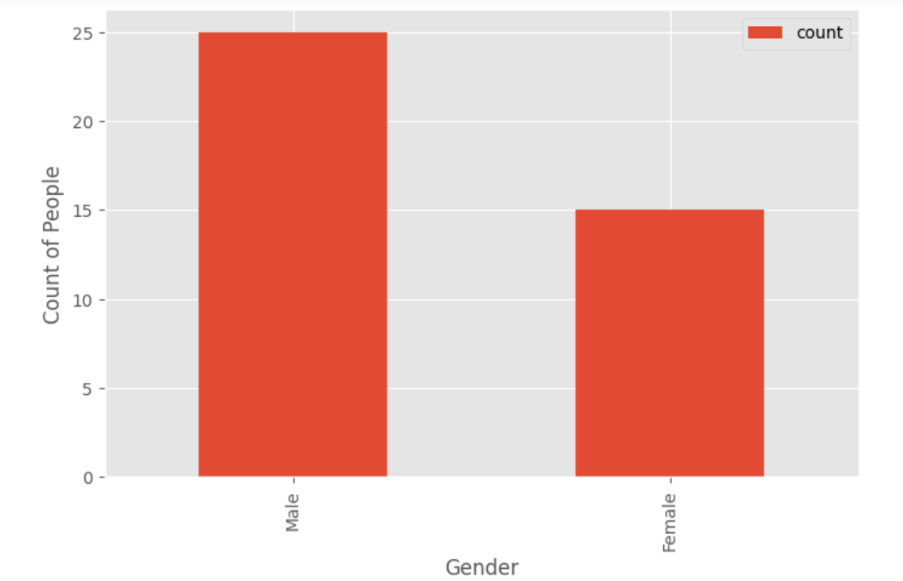

Graph Suggests that more No. of men invest in stock market than women. In our small dataset of 40 people 25 are male and 15 are female who are investing in the market.

**Frequency age range by gender**

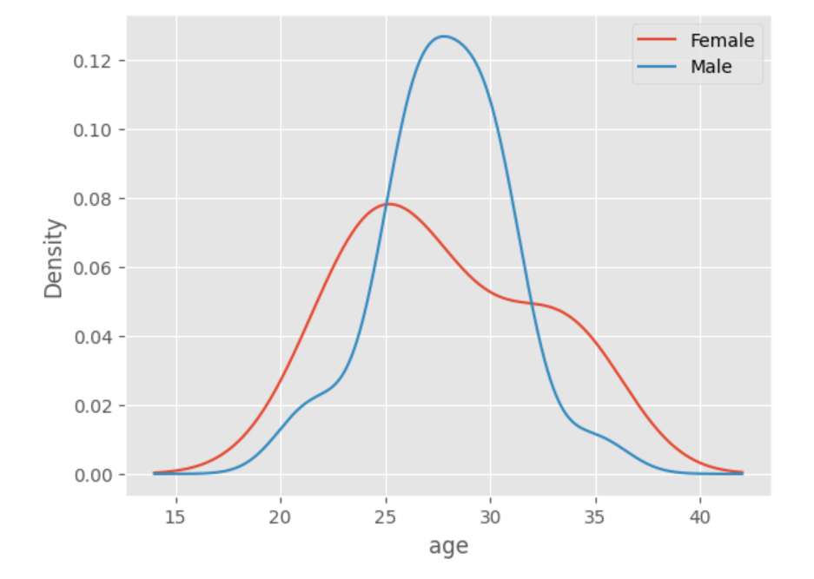

Men between the ages of 25 to 33 are likely to invest. Men aged 27 are the ones investing the most. After age 35 men are very unlikely to invest. Women between the ages of 20 to 35 are likely to invest. Women aged 25 are the ones investing the most but not as much as Men age 27.

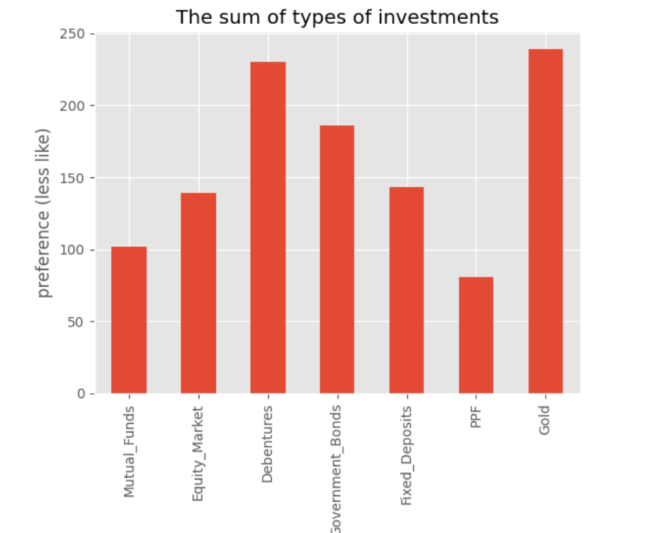

Investors often prefer allocating their funds in a sequential order, starting with gold due to its historical reputation as a stable and valuable asset. Following gold, they may consider debentures, which offer fixed returns and are considered less risky than some other investment options. Government bonds, with their backing from the government, are often viewed as secure investments, making them a logical next choice.

Moving on, investors might turn to fixed deposits, appreciating the guaranteed returns and capital preservation they provide. Equity markets come next in the sequence, offering the potential for higher returns but also carrying higher risk. Mutual funds, known for their diversification and professional management, become an appealing choice after exploring individual equities.

Finally, investors may consider Public Provident Fund (PPF), a government-backed savings scheme with tax benefits, providing a secure long-term investment option. This sequential approach reflects a balanced strategy, combining both low-risk and potentially higher-return assets in a well-thought-out investment portfolio.

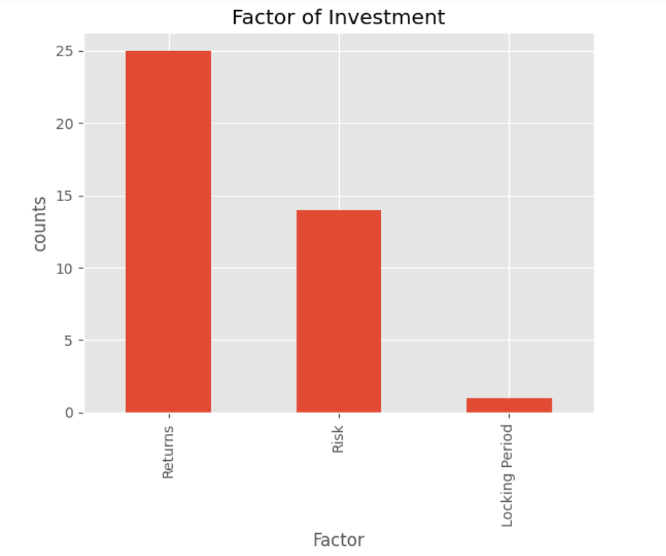

Investors often take into account various factors before making investment decisions. Among these considerations, returns play a dominant role. The potential for profitability is a primary focus for many individuals when evaluating investment opportunities. Additionally, risk holds significant importance in the decision-making process. Investors recognize the need to assess and manage the risks associated with an investment, understanding that higher returns often come with increased levels of risk.

Furthermore, following returns and risk, the locking period becomes another crucial factor in the investment decision-making process. The duration for which an investment is locked-in influences investors' liquidity and ability to access their funds. Investors may prioritize investments with lock-in periods that align with their financial goals and liquidity needs.

In summary, the interplay of returns, risk, and the locking period forms a comprehensive framework that investors consider when navigating the complex landscape of investment choices.

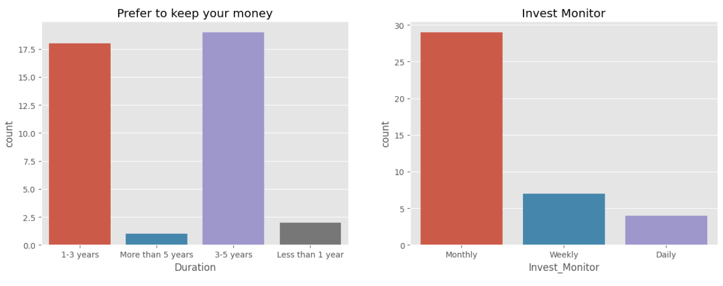

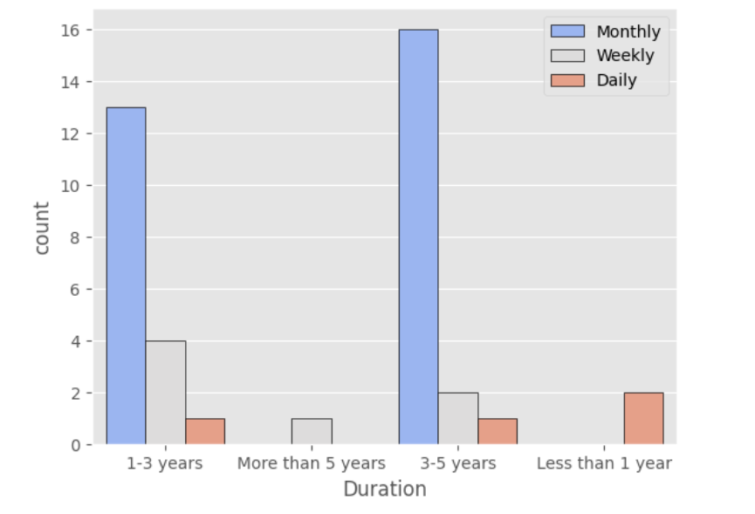

The majority of individuals express a preference for maintaining their financial investments over a duration spanning from 3 to 5 years, indicating a tendency towards a more moderate and longer-term investment approach. Conversely, a substantial number of people lean towards a shorter investment horizon of 1 to 3 years, suggesting a preference for relatively quicker returns. Additionally, there is a segment of the population seeking returns within a year, showcasing a desire for swift financial gains.

It is noteworthy that a limited number of individuals exhibit a willingness to commit their funds for a period exceeding 5 years, indicating that a prolonged investment commitment is less common among the general populace.

Furthermore, a prevalent investment practice observed among most people is the allocation of funds on a monthly basis, emphasizing a regular and systematic approach to investing. Some individuals opt for a weekly investment schedule, showcasing a more frequent engagement with the investment process. Conversely, only a small fraction of investors choose a daily investment frequency, highlighting the rarity of such a high-frequency approach in the broader investment landscape.

**Source of Financial Advice**

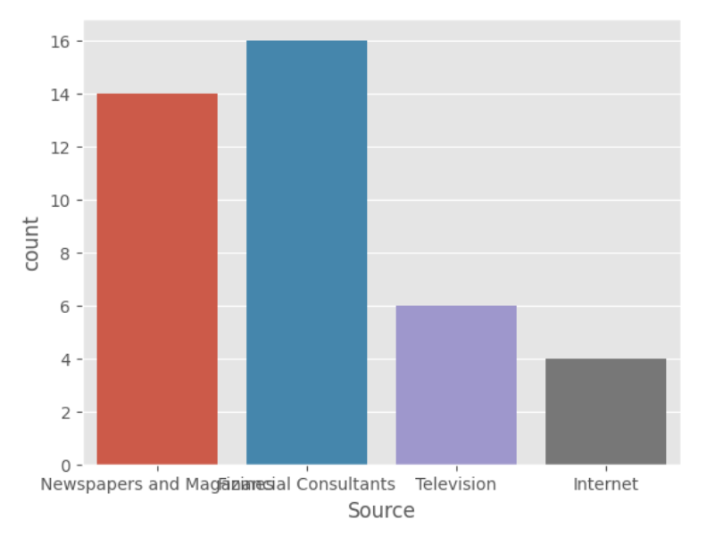

People commonly seek investment advice from financial consultants, relying on their expertise and professional insights. Additionally, some individuals turn to traditional sources such as newspapers and magazines to stay informed about potential investment opportunities. A smaller percentage of people choose to gather financial insights from television broadcasts, while an even smaller fraction looks for advice on the internet. This diverse range of information sources reflects the varied preferences and trust levels individuals place in different mediums when making investment decisions.